User Manual

MODEL:GSE027


Warning:Before using this product,please read this manual carefully!This product is intended for household or similar environments only.
Note:The product images may slightly differ from the actual product.Please refer to the actual product for accurate informatio

1. Use safety instructions

Please read the instructions in detail and keep it safe for future reference.
Please strictly follow the following instructions. Ignoring the instructions or operating errors may cause serious accidents or harm to others. Therefore, please follow the instructions. (This product is only for home use)
If the soft wire of the power cord is damaged, it must be replaced by the manufacturer or its maintenance department or similar professionals to avoid danger.

pay attention to
 | Please read the details before using this product  Read all instructions in this manual. |  | The power supply used should be voltage 220-240V current more than 10A.
 | Do not use this product beyond its functional scope. |  | Do not let children operate this product.
 | Stop using this product when the power cord or plug is broken or not functioning. |  | Do not let the power cord touch sharp edges or hot surfaces.
 | This product must be placed on a stable and reliable working table for operation. |  | When unplugging, hold the plug. Do not pull the power cord.
 | Do not use outdoors. |  | Do not immerse this product in water or any other liquid.
 | For safety, do not disassemble this product without authorization. If there is any abnormality, please send it to the company's service center or distributor for repair by qualified maintenance personnel.

2. Safety precautions

△ Warning: Be alert to the risks that may lead to danger, serious injury and heavy property loss;
△ Note: Pay attention to the risk that may cause injury or damage to property;
△ Warning: During work, please use the knob or handle. Do not touch the high temperature surface and interior of the product to avoid burns.
▲ pay attention to ：
1. Children are strictly prohibited to operate this product during use, and it should be placed in a place inaccessible to children.
2. It is strictly prohibited to use the product for any purpose other than food heating.
3. All packaging materials must be removed when using, otherwise the product will cause fire, burn and so on in the working process.
4. Ensure that the power cord is not in contact with sharp edges, burrs, other protruding sharp objects or high-heat surfaces to prevent leakage or fire.
5. Before connecting the power supply, please check whether the voltage marked on the product is consistent with the power supply voltage to avoid damaging the components or causing fire.
6. It must be used alone with a 10A or above grounded socket. The plug must be completely inserted into the socket to prevent components from overheating and burning out due to poor contact, which may cause short circuit or fire and other dangers.
7. Please operate on the horizontal platform. Do not operate on the carpet, towel plastic, paper and other flammable materials to prevent fire.
8. Do not use this product on an unstable, humid, high temperature, smooth and heat-resistant table surface, so as to avoid electric shock, fire, slip and other injuries and property losses.
9. Do not use this product in an environment with leakage and leakage, otherwise it will cause fire and electric shock.
10. Do not use this product under or near combustible materials such as curtains and wardrobes to prevent fire.
11. Do not let the product work without supervision to prevent dangerous hazards such as burning food and causing fire.
12. Before the first use, please take out the baking tray and put it into an alkaline solution to clean. After cleaning, put it into the electric oven and open the preheating for 10 minutes to eliminate the residual odor of packaging or transportation.

13. Ensure that the accessories are dry before use.
14. When using the product, enough space should be left around it and at least 10cm
away from surrounding objects to prevent oil fumes contaminating furniture, even
causing fire and other dangers.
15. This sign indicates that the contact surface temperature 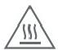may be very high,
pay attention to prevent scalding.

3. Safety precautions

1. A small amount of smoke or slight odor may be emitted when it is first used, which is normal.
2. This product should not be burned for a long time (without any ingredients). It is recommended not to use it continuously for more than 2 hours, in order to prevent self-ignition and other accidents and property losses.
3. Ensure that the food does not touch the heating tube during use. Do not roast large food, otherwise it is easy to cause smoke and fire.
4. Do not put any paper, plastic and other flammable materials in the electric oven when using it, so as to avoid fire risk.
20. Do not put glassware, closed containers and other explosive items in the electric oven for heating, so as to avoid the risk of explosion.
5. During use, do not put bagged, canned or bottled articles, cotton gauze or flammable materials on or cover the electric oven to avoid fire and explosion.
6. Do not run the product by connecting a timer or independent remote control system, in order to prevent short circuit, spontaneous combustion and other dangers.
7. The product will produce high temperature and steam during operation. Do not touch it or put your face close to it. Be very careful when pulling out the frying pan, because hot steam may come out from the electric oven.
8. When unplugging, you must hold the plug out. Do not pull the power cord hard to avoid damage to the power cord and danger of electric shock.
9. Please use high temperature insulation objects to take high temperature items, in case of burns.
10. After use, please cut off the power supply and clean the cavity after cooling the product, so as to prevent residual powder residue and oil stains from smoking or catching fire during baking.
11. If the power cord is damaged, it must be replaced by a professional from the manufacturer, its maintenance department or similar department to avoid danger.
12. If the product is faulty or damaged, please stop using it and send it to our after-sales service point for repair. Do not repair it by yourself to avoid danger.

4. Component diagram

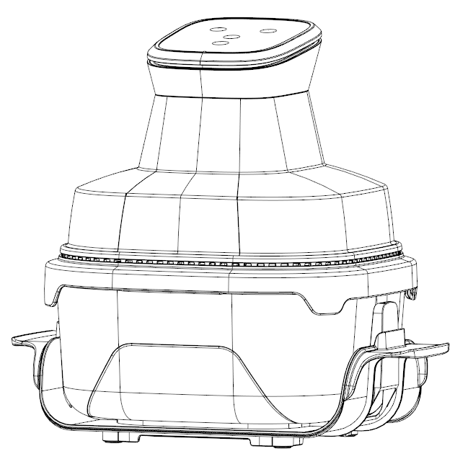

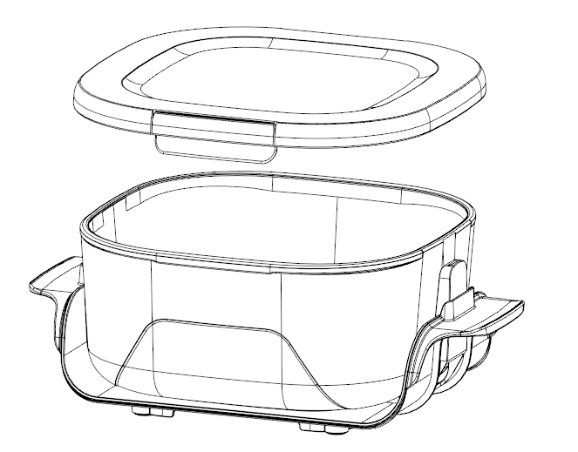

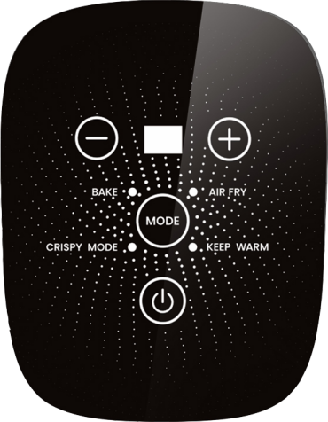

4.0L bowl
Minus key
menu
additional key
ON/OFF

5. How to use it
Preparation for the first use:
1. Remove all packaging materials.
2. Remove the frying pan and glass bowl to remove the bubble bag.
3. Clean the frying pan, baking tray and glass bowl with warm water. Wipe the stainless steel and surface of the electric oven with a wet cloth soaked in detergent. Wait until it is completely dry before using.
4. Place the electric oven on a stable surface and use a separate power cord.
5. Sufficient space should be reserved around the electric oven to ensure that there is at least 10cm distance between the surface and other objects, and no object should be placed in the air outlet.
pay attention to ：
When using for the first time, preheat the electric oven for 5 minutes to remove any residual oil and smoke. You may smell an odor when using it for the first time.
This is a normal phenomenon and not a fault of the electric oven.
direction for use ：
1. Place the food in a glass bowl on a baking tray.
2. Place it on the baking tray according to the height of the food.
3. Place the main body of the frying pan on a glass bowl and choose your favorite mode according to the recipe or personal preference.
Usage steps:
1. After the product is powered on, press it lightly and the product will be turned on with a "beep";
2. It can be pressed to select the cooking mode according to personal preference (the mode can be selected in a cycle)
3. After determining the mode and time required for cooking ingredients, please gently touch the icon on the function operation panel. (Note: If you find that the mode is wrong, you can hold down for 2S to shut down and restart the machine to select the mode.)
4. After completing the menu operation, immediately turn off the heating. The digital display will show "--". The fan will stop after a 20-second delay, accompanied by five consecutive "beep" sounds from the buzzer, then enter standby mode. During standby, only the main unit is operable; all other buttons remain inactive. At this stage, remove the main unit from the glass bowl and place it on the heat-resistant platform.
(Note: The set time and temperature are for reference only due to regional differences.)
△ Note: If you need to stop or shut down the machine, you can manually turn it off. To do this, press the button on the operation panel for 2S. The digital tube will display "--", stop heating, and the fan will stop after 20S delay)

Tips ：
- Do not use plastic or paper containers that are not heat resistant to carry food into the electric oven. Do not use glass or ceramic plates or lids.
2. You can adjust the barbecue time according to your personal taste. It is recommended that you check the food frequently during the barbecue to avoid burning it.
3. To make the barbecue and baking effect better, it is recommended to preheat for 5-10 minutes before use.
4. When the electric oven is in operation and for a period of time after the end of the operation, the temperature of the outer surface and the air outlet may be very high,
5. Do not touch or move it at will to avoid danger.
Menu parameter table:
 | Preset time is min | Preset temperature ℃ | time frame min
Default | 15 | 180 | 01~60
BAKE | 20 | 200 | 01~60
AIR FRYER | 15 | 180 | 01~60
CRISPY | 10 | 200 | 01~60
KEEP WARM | 30 | 70 | 01~60

6. Recommended vegetable operation

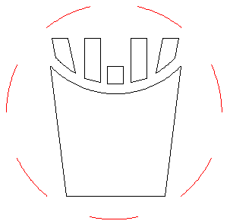
Ingredients: potato chips, oil, salt, white sesame, chili powder, cumin as appropriate.
production procedure ：
1. Wash and slice the fries
French fries
200℃
15min
2. After that, put the fries in and bake for about 5 minutes. Take out the pan and shake it back and forth. Continue baking for 3 to 8 minutes;
Note: The specific time should be slightly changed according to the size, temperature and shape of the food
Introduction For reference only. During the process, you can take out the frying pan and shake it back and forth to ensure uniform heating
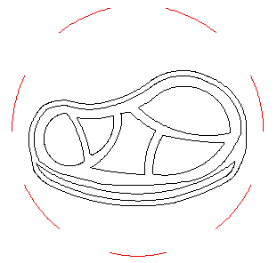
Ingredients: about 500 grams of meat, oil, salt and cooking wine as appropriate.
beefsteak
200℃
9min
production procedure ：
1. Wash the meat and cut a few cuts on the surface. Mix the seasoning evenly and marinate for about 30 minutes;
2. Put the meat in and roast for about 9 minutes;
Note: The specific time should be slightly changed according to the size, temperature and shape of the food
Introduction For reference only. During the process, you can take out the frying pan and shake it back and forth to ensure uniform heating

Ingredients: about 500 grams of chicken legs, oil, salt and cooking wine.
drumstick
180℃
20min
production procedure ：
- Clean chicken and leg, make a few cuts on the surface, mix in the seasoning evenly and marinate for about 30 minutes;
- After that, put the food in, bake for about 10 minutes, turn over, and continue to bake for 8 to 10 minutes;
Note: The specific time should be slightly changed according to the size, temperature and shape of the food
Introduction For reference only. During the process, you can take out the frying pan and shake it back and forth to ensure uniform heating
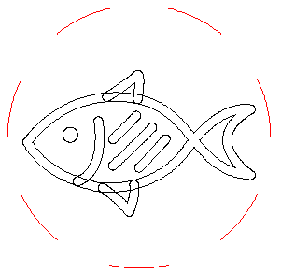
Ingredients: fish, oil, salt, barbecue sauce, cumin, cooking wine, lemon and other appropriate amounts.
production procedure ：
1. Wash the fish and cut it on the surface. Mix the seasoning evenly and marinate for about 30 minutes;
grill
180℃
16min
2. After that, put the fish in and roast for about 12-16 minutes;
Note: The specific time should be slightly changed according to the size, temperature and shape of the food
Introduction For reference only. During the process, you can take out the frying pan and shake it back and forth to ensure uniform heating
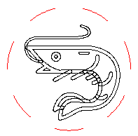
Ingredients: prepare 10 medium-sized prawns, cooking wine, salt and ginger slices
Grilled shrimp
200℃
6min
production procedure ：
1. Remove the shrimp from the line. Mix the seasoning evenly and marinate for about half an hour. When the time is up, dry it. 2. Sprinkle starch on the shrimp and wrap them in the air fryer. Spray a layer of vegetable oil on the shrimp.
3. Turn the temperature to 200 degrees, bake for 3 minutes, refill with oil, and bake for another 3 minutes with the other side on.
Note: The specific time should be slightly changed according to the size, temperature, shape and other dishes
Introduction For reference only. During the process, you can take out the frying pan and shake it back and forth to ensure uniform heating

Ingredients: 40g low gluten flour, 2 eggs, 20g milk, 40g sugar, 20g rice oil, 2 drops white vinegar
1. Separate the egg yolk from the egg white. Beat the egg white into a fat-free, water-free container. Add the egg yolk and 20 grams of sugar to the container and beat.
cake
180℃
20min
2. For the egg white, add 2 drops of white vinegar and 20 grams of sugar in 3 separate batches. Add the sugar for the first time when the fish eye foam appears. Add the sugar for the second time when the egg white develops fine lines. Add the sugar for the third time and whip the stiff egg white until it forms an unbroken hook when lifted with a whisk.
3. Beat the whipped egg white into the egg white three times and stir it up and down to avoid deflating the egg white.
4. Mix the batter into a mold. Preheat the air fryer to 180 degrees for three minutes. Place the cake mold in the air fryer. Bake at 180 degrees for 10 minutes, then turn it over to 180 degrees for another 10 minutes.
5. Sprinkle some milk powder on the finished cake to decorate it
Note: The specific time should be slightly changed according to the size, temperature and shape of the food
Introduction For reference only. During the process, you can take out the frying pan and shake it back and forth to ensure uniform heating
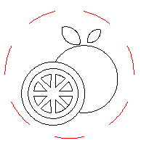
Ingredients: Pomelo, orange, kiwi, lemon and pineapple in appropriate amounts.
production procedure
1. Cut the fruit into slices and place on a baking tray
2. Air fryer 70℃ Cook for 30 to 120 minutes
dried fruit
70℃
60min
Note: The specific time should be slightly changed according to the size, temperature and shape of the food
Introduction For reference only. During the process, you can take out the frying pan and shake it back and forth to ensure uniform heating

7. Cleaning and maintenance

1. Before cleaning the electric oven, please disconnect the power supply and unplug it first. Wait until the electric oven is completely cooled before proceeding.
2. If there is oil stain in the electric oven, wipe it with a soft wet cloth soaked in neutral cleaner.
3. Clean all accessories including the frying pan and basket with a neutral detergent.
4. Do not immerse the whole electric oven in water or other liquids for cleaning, so as to avoid the risk of electric shock or functional failure.
5. After cleaning, wait for the product to dry and then store in a cool and dry place.

8. Product technical parameters

type | product model | rated voltage | rated frequency | power rating
Electronic version | GSE027 | 220-240V | 50/60Hz | 1500W

9. Abnormality analysis and processing

phenomenon | cause | processing method
The product is not working | The power supply is not plugged in | Plug the power cord into a ground outlet.
The product is not working | The pot was not pushed all the way | Push the pan parallel to the bottom.
No fried food | There's too much food on the grill | If you have too much food, put it in batches on the tray.
No fried food | The cooking time was too short | Increase cooking time.
The food was not fried evenly | It was not shaken during cooking | Some of the overlapping or interlocking foods can be removed from the frying pan and shaken appropriately during cooking.
The food doesn't crack when fried | No traditional fried ingredients are used | Appropriate fried snacks can be used. If there is no oil, a light brush of oil can be applied to the surface.
White smoke came out | The greasy ingredients are being baked | It is normal to have a lot of smoke leakage when baking greasy ingredients.
White smoke came out | There are still residues of the oil and fat from the last baking in the frying pan | Be sure to clean the frying pan after each baking.

10. Name and content of toxic or harmful substances or elements in the product

Part name | Toxic or harmful substances or elements
Part name | lead （Pb） | mercury （Hg） | cadmium （Cd） | Hexavalent chromium (Cr(VI) | Polubenzopyrene (PBB) | Polybrominated diphenyl ethers (PBDE)
hull | 0 | 0 | 0 | 0 | 0 | 0
Motor assembly | X | 0 | 0 | X | X | X
ovenware | 0 | 0 | 0 | 0 | 0 | 0
Power cable assembly | X | 0 | X | 0 | X | X
Internal wiring components | 0 | 0 | 0 | 0 | 0 | 0
Motor cover | 0 | 0 | 0 | 0 | 0 | 0
lampstand | 0 | 0 | 0 | 0 | 0 | 0
Base housing | 0 | 0 | 0 | 0 | 0 | 0
loam cake | 0 | 0 | 0 | 0 | O | 0
heating tube | 0 | 0 | 0 | 0 | 0 | 0
nut bolt | 0 | 0 | 0 | 0 | 0 | 0
metallic gasket | 0 | 0 | 0 | O | O | 0

