INSTRUCTION MANUAL

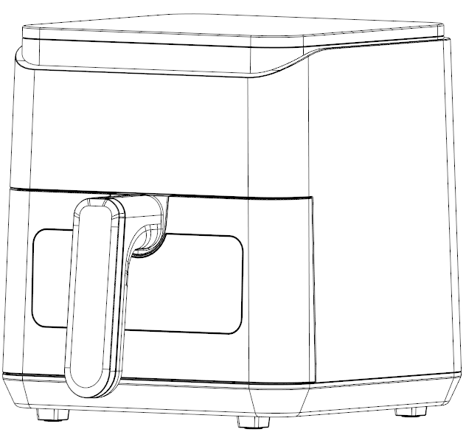

4L Air Fryer
MODEL: GSE028FT

HOUSEHOLD USE ONLY

Please read the manual carefully before use.
Thank you for your purchase of our air fryer. To confirm correct operation and your safety, please read this manual carefully before use and retain it for further reference.
IMPORTANT SAFEGUARDS

- This product is not intended for use by children. Keep the product out of the reach of children and pets. Extra caution is necessary when using this appliance near children.
- Always ensure the product is unplugged from the electrical outlet and allowed to cool before assembling, disassembling, relocating, or cleaning it.
- DO NOT leave the product unattended while it is in use. Always unplug the product from the electrical outlet when not in use.
- DO NOT immerse the base, power cord, or plug of this product in; or expose the power cord or plug to water or other liquids.
- Take proper precautions to prevent burns, fire, or personal or property damage.
- DO NOT use attachments not recommended or sold by the product manufacturer. Attachments may become hot during use. Allow any attachments to cool before handling them.
- DO NOT place on or near a gas or electric burner, in a heated oven, or other heated surfaces.
- Use extreme caution when moving an appliance containing hot food, water, or other liquids.
- Use the product in a well-ventilated area. Keep at least 4-6 inches of space on all sides of the product to allow adequate air circulation.
- Use appliance on a table or flat surface.
- Keep the product away from curtains, wall coverings, clothing, dishtowels, or other flammable materials.
- DO NOT plug or unplug the product from the electrical outlet with a wet hand.
- This product is intended solely for non-commercial, non-industrial, household use in cooking food for human consumption; DO NOT use the product outdoors or for any other purpose.
- DO NOT let the cord hang over the edge of a table or counter where it may be tripped over or pulled.
- DO NOT allow the cord to touch hot surfaces.
- DO NOT operate the appliance if it has a damaged power cord or plug, if wires are exposed, if it malfunctions, if it is dropped or damaged, or if the motor housing is dropped in or exposed to water.
- This product has no user-serviceable parts.
- DO NOT attempt to examine or repair this product yourself. Only qualified service personnel should perform any service.
- DO NOT put any stress on the power cord where it connects to the product, as the power cord could fray and break.

INTRODUCTION
This air fryer offers a simple and healthy way to prepare your favorite foods. Using rapid hot air circulation and a top grill, it cooks a variety of dishes evenly. Best of all, it heats food from all directions, often requiring little to no oil.

SPECIFICATIONS
Model | GSE028FT
Wattage | 1200 W
Voltage | 220-240V 50/60Hz
Capacity | 4L
Temperature Range | 80-200℃
Timer | 1-60 Minutes

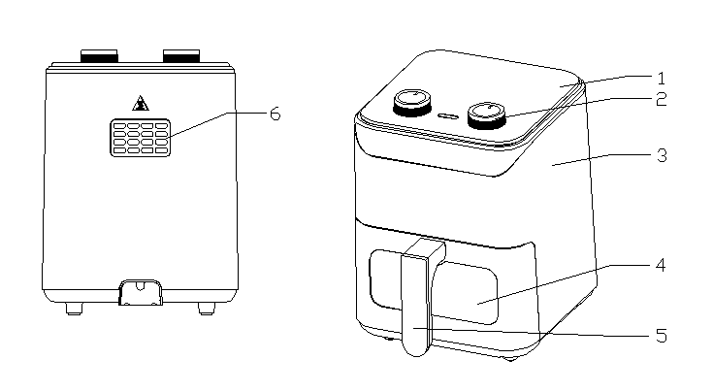
COMPONENTS
1.Digital menu
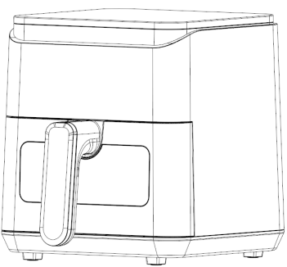
2.Body

3.Window

4.Handle

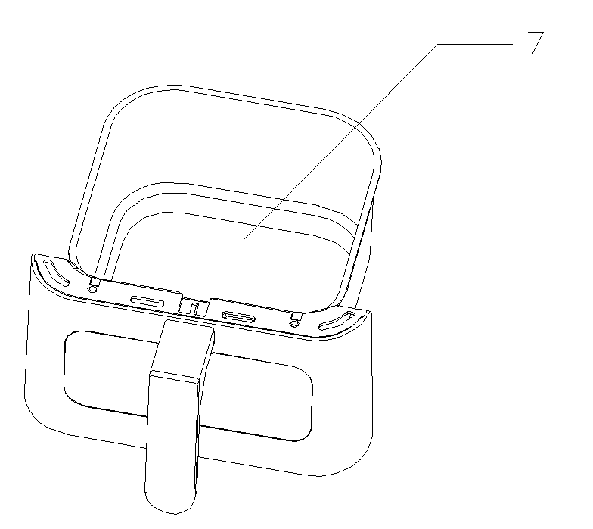
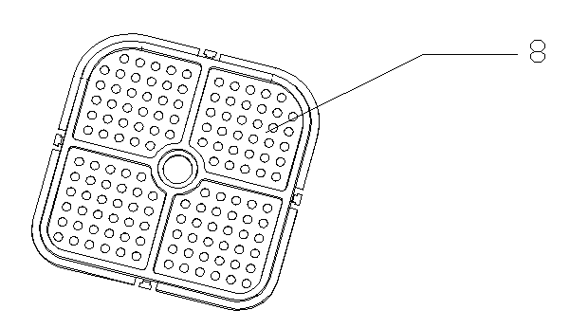

1. Digital menu | 5. Air Outlet
2. Body | 6. Fryer Basket
3. Window | 7. Grill Rack
4. Handle

Temperature
Turn the Temperature Control Knob in either direction to set your desired temperature. The temperature can be adjusted from 180°F to 400 °F.

Indicator Light
The green indicator light turns on when the air fryer is powered on. The red indicator light turns on when the temperature exceeds a certain level and turns off once it drops below that point, cycling repeatedly (as shown).

Note: During oven operation, the heater will turn off if the chamber temperature becomes too high. Once the temperature drops below the preset level, the heater will resume heating. This cycle repeats to maintain an optimal baking temperature.

Timer Control Knob
- The Timer Control Knob can be set to a maximum of 60 minutes. When set to "0", the air fryer will be powered off.
- Turn the Timer Control Knob clockwise to the desired cooking time. When the set cooking time is complete, a “ding” will sound.

Before First Use

- Remove all the packaging materials.
- Thoroughly clean the air fryer basket and grill rack with hot soapy water and non-abrasive sponge.
- Wipe the inside and outside of the air fryer body with a damp cloth. Dry thoroughly.
- Place the air fryer on a stable, level surface.
DO NOT place the appliance on a non-heat-resistant surface.
- Allow enough space around the oven to ensure that the surface is at least 4” away from other objects and that no objects are placed on the air outlet.

PLEASE NOTE: When your air fryer is heated for the first time, it may emit slight smoke or odor. This is normal with many heating appliances. This does not affect the safety of your appliance.
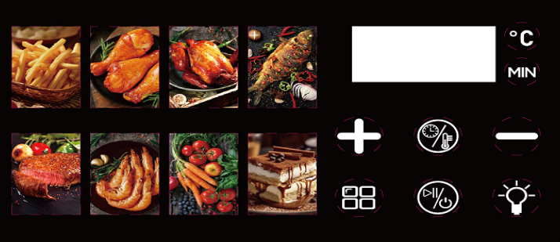
Cooking Reference Menu
 | Menu Item | Temp ℃ | Time (Mins)
#1 | French fries | 200 | 15
#2 | Chicken wing | 200 | 25
#3 | Chicken | 200 | 25
#4 | Fish | 200 | 20
#5 | Steak | 180 | 30
#6 | Shrimp | 180 | 15
#7 | Vegetable | 160 | 10
#8 | Bake | 180 | 15
 | Timer |  | 1-60mins
 | Temp | 80-200℃
The above is for reference only. You can manually adjust the temperature and cooking time as needed.
Cleaning and Storage

- Before cleaning the air fryer, turn the Temperature Control Knob and Timer Control Knob to 0; unplug the appliance and wait for the appliance to cool down.
- Never immerse the device in water or any other liquid. The device is not dishwasher safe.
- Clean the surface of the fryer basket and grill rack with hot soapy water, and a non-abrasive sponge.

Tip: If dirt is stuck to the grill rack or the bottom of the basket, fill the basket with hot soapy water. Put the grill rack in the basket and allow them to soak for 10 minutes.

- Use a damp cloth to wipe the surfaces of the air fryer. Never use harsh or abrasive cleaners, scouring pads or steel wool, which can damage the protective coating.
- If you do not use the appliance for a long time, please clean it, and store it in a cool and dry place.

